**User Manuel**

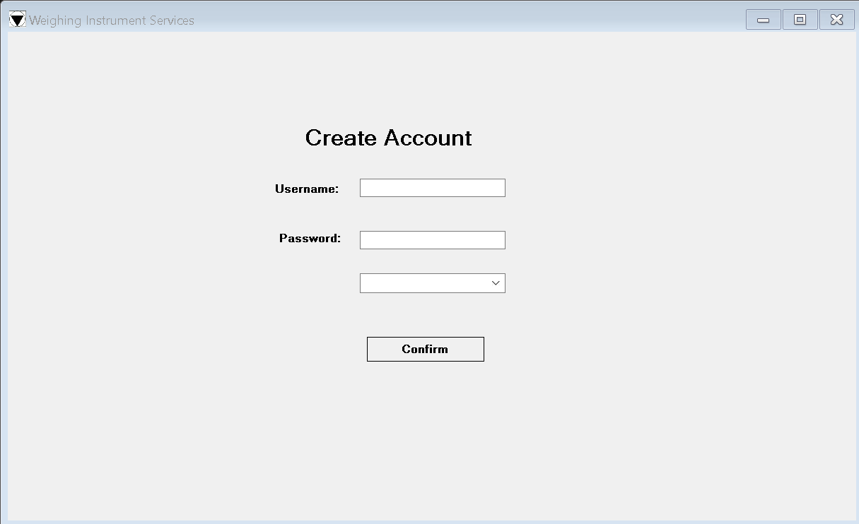

The above image is the Register window you will be required to create an account before you use the software. To create an account, fill in the blank field Username with your name and then fill the password field with a password that you won’t forget. After this is completed, you will be required to choose what field you are in from the dropdown menu whether it be finance or a general user. Once these steps are completed you should select the Confirm button to save the inputted data as your account credentials. You will use these credentials for the login process.

The above image is the Login this is where you will be required to enter the credentials. You would have received a department code before you log in, enter this code into the department field, once this is done you should fill in the username and passed fields with the username and password you set submitted in the register form. Once this is done select Login. (Department codes Finance: F1289NC and General: G4578RL)

This is the view all window it displays the current stock in the system the controls on this windows are for viewing the data , it does allow for data updates ,it allows the user to reseeded data ,select a item type from the dropdown box this consists of scales, load cells, weights, weight sets, misc you can then specify the Brand with the dropdown box consisting of Axis , DA ,GC-L, CA ,AGT-S Etc., To the left of that you see Category which consists of Load cells ,new scales, outside stock room weights, weight sets ,ect and to the left of that you will see the Sub-Category dropdown box that consists of of middle garage , outside garage ,upstairs stock etc.. The search lets you search for a specific brand of scale or weight you may also search for Titles; the Total of the displayed stock is shown as well. To up date an item you will use the update item area on the far right of the application, by stock id you will enter the Id of the stock and the date, if there is no date then check the no date box, the unit numerical up down selector will let you update how many units of stock for a specific item there is and bellow that the price this will let you update the price of the specified product. To move to the insert data window, select the insert tab located at the top left of the application.

This window is used to input the stock data into the database, to do this you enter the brand name first, select the brand from the drop down list followed by the title of the product ,after this you can select a date for the stock being added if no date is required then cheque the no date box ,then you enter the price per unit and the category from the dropdown list of the provided categories ,if you are required to enter a sub category then select a sub category after this is done ,select a sub category.in the event you select scale for the type id you will notice input for scales appear fill in the limit ,limit unit and the dimensions for the width, if the scale is waterproof then select the round circle if not leave it blank and submit your data. If the type id is weight fill in the mas of the weight and the unit of mass and submit. If you selected type id weight set data fill in the min mass amount followed by the min mass unit and the same for the max, then submit. If you selected Load cell data for the type id enter the mass and mass unit and submit.in the event you select the misc data as the type id write a short technical description with the relevant information and submit that.